COMMON ELEMENTS

In this chapter some of the elements that are common for all the functions such as code format, instructions for use on various operating systems, elements of the input/output, and the GetData function are described.

IRF Formatting:
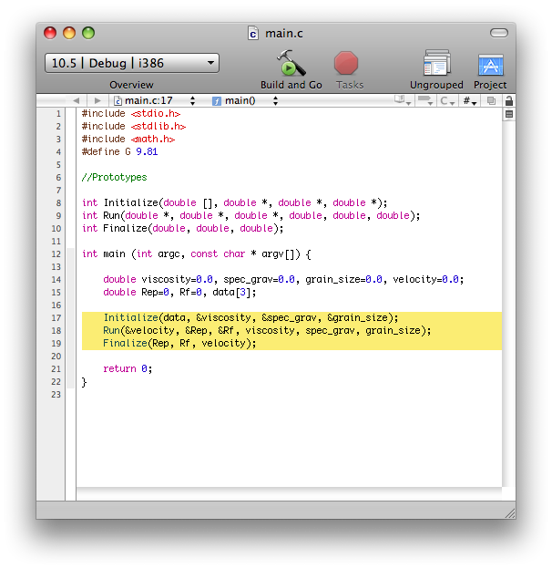
The code has been written to fit the Initialize, Run, Finalize format, as shown in the Figure. The Main function for each program includes all the data structure preparation (variable declaration, data structure definitions, etc.) and the three functions called Initialize, Run, and Finalize. What each consists of is explained below:
I The Initialize function contains the sub-functions that a) call the data from the user’s inputted text file, b) compute the constant parameters that will be used by the Run function to carry out the calculations, and c) prepare the data for use later on.
R The Run function contains sub-functions that actually do the calculations. In codes with a time loop, the Run function calls all the sub-functions needed in the time loop. In codes without any time loop, it is simply the function that carries out the calculation.
F The Finalize function sends the output to the user. It organizes the data computed by the Run function, and prints it out to a tab separated text file.

In the main function of some models there is another function called SaveDatatoMatrix, which is called after the Run function to store the data in a matrix.

Input/Output:
The models are organized in folders. Each folder also contains the documentation that describes the input/output tab separated text files. The documentation consists of three or four text files that are called Key for Inputs.txt, test.txt, Output.txt and Output1.txt.
The Key for Inputs file explains how to prepare the input text file. In particular it contains information on a) the format of the text file, b) the units of the input parameters, and c) the physical meaning of the input parameters.
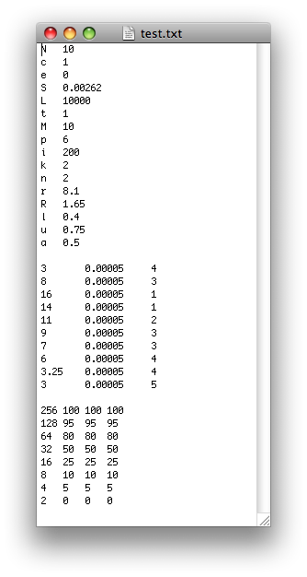
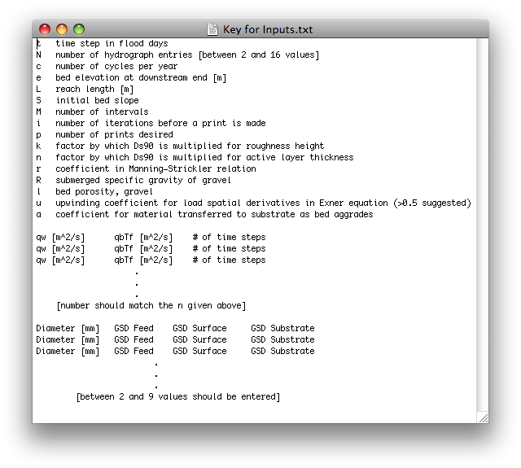
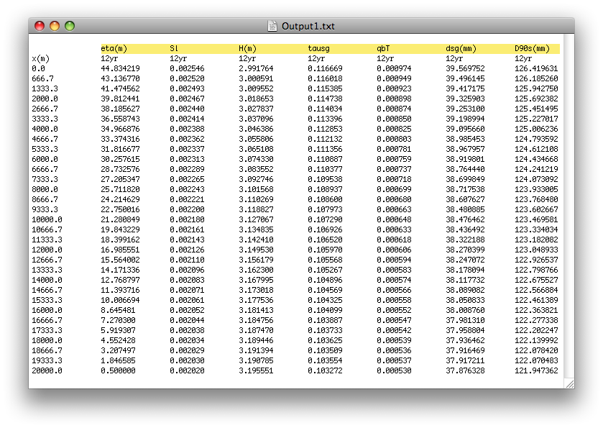
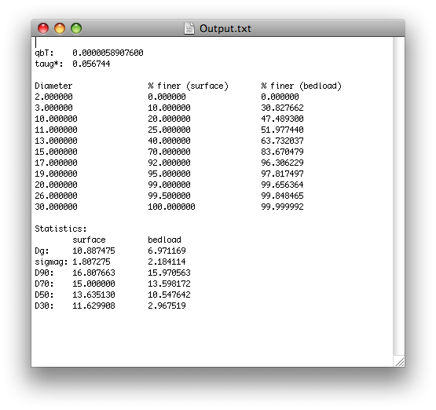

The test file is an example of an input file that has been run during the test of the model. In the Output file the results of the Test run are reported. When the user opens the output file, the data may look somewhat convoluted at first, but once the text file is resized, they should line up in nice columns (see figure below). Some of the folders contain a fourth text file called Output1, which is the text file that contains the information stored by the GetData function.
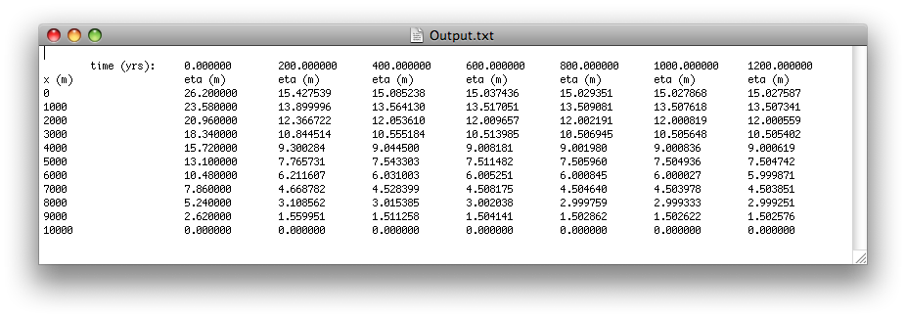
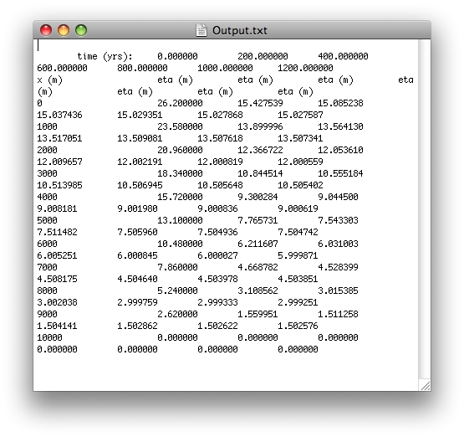

A synthetic description of the input and output parameters of the codes is reported in the continuation of this User’s Guide. For a more detailed description of the problem and of the models the user should refer to Gary Parker’s e-book 1D Sediment Transport Morphodynamics with applications to rivers and turbidity currents (simply called e-book in the continuation of the guide) downloadable at
http://vtchl.uiuc.edu/people/parkerg/morphodynamics_e-book.htm.

GetData Function:
The GetData function is included in all the codes with a time loop to store additional information at each time step that might be useful for the user.
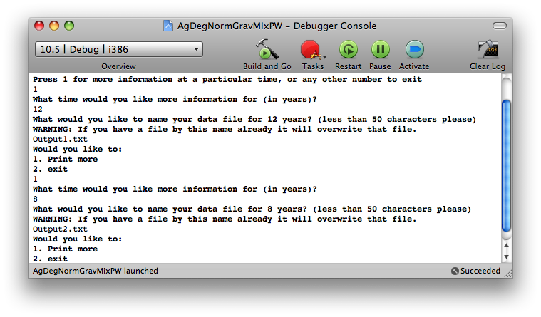
For example, if the program outputs the bed elevation, the GetData function allows the user to get additional information (i.e. water depth, sediment transport rate, shear stress, etc.) in the computational nodes. Values of the additional parameters are stored when the code sends the main output parameters. If Output.txt contains data for year 1, 2, 3, 4, and 5, then the program has not stored the data for year 2.5. In order to have information at t = 2.5 years, the user has to go back to the input file, and edit their initial parameters in order for the program to store the data at that time. The GetData function is called in the Finalize function.

Operating Systems:
The codes of the 1D Sediment Transport Morphodynamics C Function Library can run on various operating systems (i.e. Macintosh, Linux and Windows). In each folder there is a file with the extension .xcodeproj which is for use on a Macintosh computer. The active directory folder is the same folder in which all the text documents are stored. For documentation on XCode, see the following site
http://developer.apple.com/documentation/DeveloperTools/Xcode-date.html .
Otherwise, for use on a Linux machine, set the active directory to the folder in which all the .c documents are stored, and compile with
gcc –Wall <insert the names of all the functions here> -lm
The –lm is important, because the programs use the <math.h> library, and therefore they will not compile properly without it.

1) Fall Velocity

The program computes the settling velocity, v_{s}, of a particle with the formulation of Dietrich (1982). Input parameters are, as shown in the windows below, the sediment particle size, D, the kinematic viscosity of the liquid, ν, the acceleration of gravity, g, and the submerged specific gravity of the sediment, R, defined as (ρ_{s}-ρ)/ρ, where ρ_{s} and ρ respectively denote the densities of the water and of the sediment.

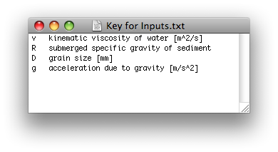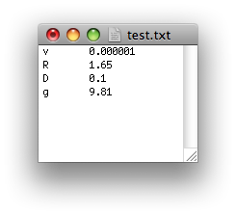

Outputs of the model are, the particle (or grain) settling velocity in cm/s, the particle Reynolds number Re_{p} and the dimensionless fall velocity R_{f}, as shown in the window below. These last two non-dimensional parameters are respectively defined as:
and (1.i)

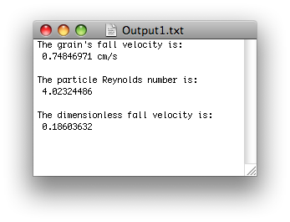

For a more detailed description of the theoretical formulation of the problem and of the code, the user should refer to Chapter 2 “Characterization of Sediment and Grain Size Distributions” of the e-book.

Notes:
- This formulation is only valid for Reynold’s numbers less than or equal to 2.5·10⁶. If R_{ep} is greater than this upper limit, the function will alert the user, and exit the program.

List of variables
INPUT
ν kinematic viscosity of water in m²/s;
R submerged specific gravity of sediment, nondimensional
D grain size in mm;
g acceleration of gravity in m/s²;

OUTPUT
v_{s} particle settling velocity in cm/s;
Re_{p} particle Reynolds number;
R_{f} dimensionless fall velocity.

References:
Dietrich, E. W., 1982, Settling velocity of natural particles, Water Resources Research, 18 (6), 1626-1982.

2) Rouse-Vanoni Equilibrium

The program computes the Rouse-Vanoni profile of suspended sediment concentration at equilibrium. For a more detailed description of the formulation the user should refer to Chapter 10 of the e-book “Relations for the Entrainment and 1D Transport of Suspended Sediment”.

The parameters of the model are:
a) H, water depth (see Figure below);
b) ζ, vertical coordinate in the cross section, i.e. ζ = 0 on the bed surface and ζ = H on the water surface (see Figure below);
c) ζ_{b}, position near the bed surface where the volumetric concentration of suspended sediment is equal to c_{b} (see point g below);
d) u*, shear velocity;
e) v_{s}, particle settling velocity computed with the formulation presented by Dietrich (1982) described in the previous chapter;
f) c, concentration of suspended sediment in the water column at elevation ζ averaged over turbulence;
g) c_{b}, concentration of suspended sediment in the water column at ζ = ζ_{b} averaged over turbulence. c_{b} can computed, for example, with one of the entrainment relations presented in Chapter 10 of the e-book.

H
η
z
Water Surface
Channel bed
Datum
0

The non-dimensional expression of the Rouse-Vanoni profile is
(2.i)
where k denotes the constant of VonKarman, set equal to 0.4, z is a non-dimensional vertical coordinate defined as ζ/H and b is the non dimensional near-bed distance equal to ζ_{b}/H.

Input parameters for the model are the non-dimensional distance from the bed surface where c_{b} is computed, b, the settling velocity of the particles, v_{s}, in cm/s and the shear velocity, u*, in m/s. In the windows below the files “Key for Inputs.txt” and “test.txt” are represented.
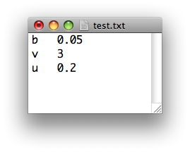
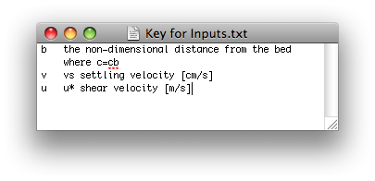
The output of the model is the non-dimensional equilibrium profile of suspended sediment concentration, i.e. the height in the water column is expressed in terms of z = ζ/H and the volumetric concentration averaged over the turbulence as c/c_{b}, in the next window the output text file is represented.
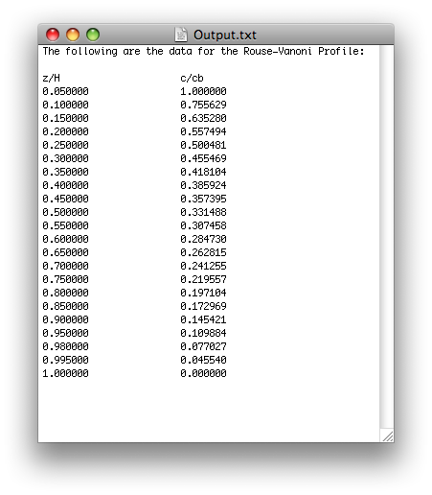
Notes:
- To compute the equilibrium profile the user can choose between
  - the grid of the excel workbook RTe-bookRouseSpreadsheetFun.xls. This grid has 22 points in the vertical direction. The lowest 19 are equally spaced between z = b and z = b + 18(1-b)/19. The upper three points are located at z = 0.98, z = 0.995 and z = 1, where the concentration of suspended sediment goes to zero;
  - an equally spaced grid with a user specified number of points in the vertical.

List of variables

H water depth in m;
ζ dimensional vertical coordinate, ζ = 0 on the channel bed and ζ = H at the water surface;
z non-dimensional height in the water column equal to ζ/H;
c volumetric concentration of sediment averaged over turbulence;
c_{b} volumetric near-bed concentration of suspended sediment averaged over turbulence, i.e. value of c at elevation ζ_{b};

INPUT
b non-dimensional distance from the bed where c = c_{b}, b = ζ_{b}/H;
v settling velocity of the particles in cm/s;
u* shear velocity in m/s;

OUTPUT
Non-dimensional profile of suspended sediment concentration in a two-column tab separated text file. In the first column the user finds the non-dimensional height of the point in the water column and in the second column the corresponding ratio c/c_{b} is reported. For ζ = b, c/c_{b} = 1 and for ζ = 1, c/c_{b} = 0.

3) GSD Calculator

Given a grain size distribution, the program computes the geometric mean diameter, D_{g}, the geometric standard deviation, σ_{g}. Characteristic diameters based on percent finer, D_{x} (i.e. size such that x percent of the sample is finer than D_{x}) can also be computed if requested by the user.
If the inputted size distribution does not have a lower bound, D_{xL}, such that xL = 0 and an upper bound, D_{xU}, such that xU = 100, the program computes these bounds with a linear interpolation of the data. To linearly interpolate the data and to perform the calculations the code uses the ψ scale defined as
(3.i)
where D is expressed in millimeters.
For a more detailed description of the theoretical formulation of the problem and of the code, the user should refer to Chapter 2 “Characterization of Sediment and Grain Size Distributions” of the e-book.

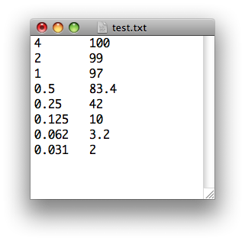
The input grain size distribution is specified, as indicated in the text files “Key for Inputs” and “test” represented in the windows below, in terms of M+1(with M < 100) bound diameters in millimeters and the corresponding value of percent finer (or passing) with a scale that can be either 0 - 1 or 0 - 100.
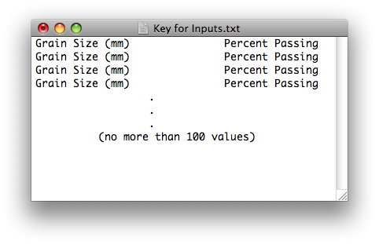

The output file, shown in the next window, is organized as follows. First the grain size distribution used in the calculations is reported, and then the values of the geometric mean diameter and standard deviation are printed. Finally the computed characteristic diameters based on percent finer, D_{x}, are reported, if requested by the user
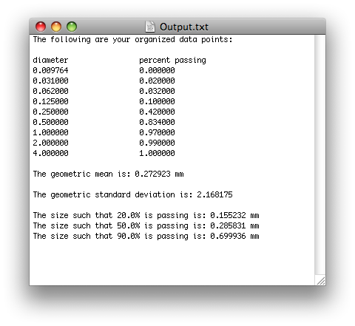

Notes:
- Input data may be entered either from the finer to the coarser size or from the coarser to the finer. The program will automatically reorder the data;
- Data may be on either a 0.00-1.00 scale or a 0-100 scale. The program will always use a 0-1 scale to do the calculations;
- If there are no lower and upper bounds in the inputted distribution such that their percent finer are respectively equal to 0 and 100 (or 1), the program will compute these bounds with a linear interpolation on the ψ scale and will add these diameters to the input size distribution;
- The program will prompt users if they want to calculate characteristic diameters based on percent finer, D_{x}, and what diameters they would like to know;
- The program can calculate up to 10 characteristic diameters based on percent finer;
- The geometric mean diameter, D_{g}, the geometric standard deviation, σ_{g}, and the user-defined characteristic diameters based on percent finer will be appended to a file with the reorganized, scaled, and bounded grain size distribution

4) Backwater Calculator

The program solves the backwater equation for subcritical flow with a predictor – corrector scheme. To compute the water depth, H, everywhere in the channel for a given water discharge per unit channel width, q_{w}, and downstream boundary condition, i.e. a user specified water depth, the equation is formulated as
(4.i)
where x is a streamwise coordinate, S denotes the bed slope, S_{f} the friction slope, and Fr is the Froude number.
The bed slope, S, is assumed constant in the streamwise direction, the friction slope, S_{f}, and the Froude number, Fr, are defined below
(4.ii a, b)
where C_{f} represents a non-dimensional friction coefficient that can be evaluated with both a Chézy and a Manning-Strickler formulation, and g is the acceleration of gravity.
In the Chezy formulation (that is implemented in the excel workbook RTe-bookBackwate.xlsr) the friction coefficient is a user specified constant in space and time:
(4.iii a, b)
where Cz denotes the non-dimensional Chezy friction coefficient and K_{cz} is the dimensional Chezy friction coefficient.
In the Manning-Strickler formulation the friction coefficient is a function of the water depth. In the present model it is assumed that the cross section is wide, therefore the friction coefficient is computed as
(4.iv)
where α_{r} is a user specified parameter and k_{s} is a roughness height due to skin friction defined as
(4.v)
For a more detailed description of the theoretical formulation of and of the code, the user should refer to Chapter 5 “Review of 1D open channel hydraulics” of the e-book.

Input parameters of the model are the bed slope, S, the water discharge per unit width, q_{w},a starting water depth at the downstream end of the channel, H₁, a spatial step length, Δx, and a starting point x. If the user wants to perform the calculation with a Chezy formulation, he should also input the non-dimensional Chezy friction coefficient, Cz, defined in equation (4.iii a, b). If a Manning-Strickler formulation is chosen, the user is asked to input the parameter α_{r} in equation (iv) and the parameters to evaluate the roughness height, k_{s}, i.e. the coefficient n and the D₉₀ of the bed surface defined in equation (4.v). The text file with the definition of the input parameters and an example of input file are shown in the two windows below.
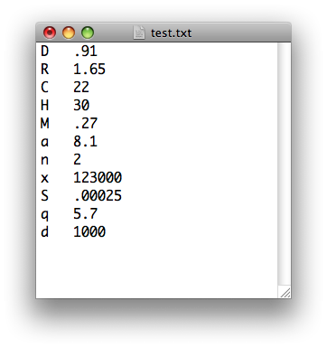
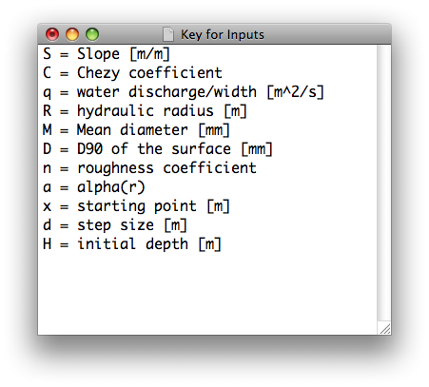
Output parameters of the model are the water depth, H, the mean flow velocity, U, the shear stress, τ_{b}, the bed elevation, η, and the water surface elevation, ξ, equal to the sum of the bed elevation and the water depth. In the output file water depth, mean flow velocity, Froude number and shear stress are also reported for normal flow conditions with the critical values of water depth and mean flow velocity. An example of the output file is reported in the window below.
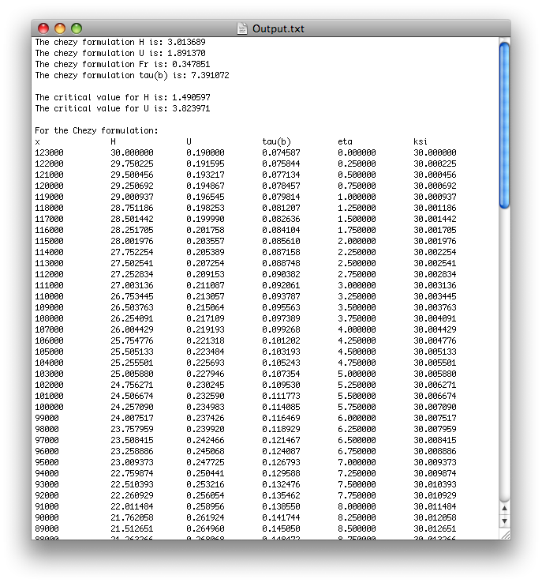

Notes:
- The program will automatically recognize the formulation (i.e. Chezy or Manning-Strickler) the user wants to implement from the input file. If a value of the Chezy friction coefficient is specified in the input file but the parameters to compute the friction coefficient with equation (4.v) are not given, the code will use a Chézy formulation. On the contrary, if values for α_{r}, D₉₀ and n are specified while there is no Chezy friction coefficient in the input file, the program will automatically use a Manning-Strickler formulation. If all the four parameters are specified, the program will ask the user which formulation he would prefer to use

List of variables

x streamwise coordinate, in m

INPUT
S bed slope
q_{w} water discharge per unit width in m²/s
Cz non-dimensional Chézy friction coefficient
D₉₀ diameter of the bed surface such that 90% of the distribution is finer in mm
n parameter to compute roughness height with equation (v)
α_{r} dimensionless constant in equation (iv)
x₁ starting position in m
Δx step size in m
H₁ initial depth in m
OUTPUT
H water depth in m
U mean flow velocity in m/s
tau(b) shear stress on the bed surface in N/m²
eta bed surface elevation in m
csi water surface elevation in m
H_{n} water surface at normal flow in m
H_{c} critical water depth in m
Fr_{n} Froude number at normal flow
U_{n} mean flow velocity at normal flow in m/s
U_{c} critical flow velocity
tau(b)_{n} bed shear stress at normal flow in N/m²

5) AgDegNormal

The program calculates a) an ambient mobile-equilibrium sediment transport rate and b) the morphodynamic evolution of a reach due to a change in sediment input rate. For a detailed description of the theory and of the model, the user should refer to Chapter 14 “1D aggradation and degradation of rivers: normal flow assumption” of the e-book, and to the word file RTe-bookAgDegNormalFormul.doc, downloadable at
http://vtchl.uiuc.edu/people/parkerg/word_files.htm.

The assumptions and the simplifications at the basis of the formulation are:
- the quasi steady approximation (deVries, 1965), i.e. the bed changes so slowly compared to the characteristic response time of the flow that the flow can be approximated as responding immediately. This assumption greatly simplifies the problem, but it limits the applicability of the model. In particular, this model cannot be applied in cases when a) it is desired to characterize the sediment transport over an entire rapidly varying hydrograph; b) one wishes to capture the effect of a flood wave (with a high water surface slope on the upstream side of the wave and a low water surface slope on the downstream side) on sediment transport; and c) the flow makes transitions between subcritical and supercritical flow, in which case a shock-capturing method capable of automatically locating hydraulic jumps is required. For more information on the quasi- steady approximation, the user can refer to Chapter 13 “The quasi-steady approximation” of the e-book;
- the channel width, B_{c}, is constant in the streamwise direction and in time;
- the floodplain is absent;
- the flow is assumed normal;
- the sediment is uniform;
- the Exner equation of channel bed sediment conservation is based on the computation of total bed material load;
- the relevant morphodynamic changes of the river occur during floods. The full hydrograph or flow duration curve is replaced by flood intermittency factor, I_{f}, (Paola et al., 1992) and a constant flood discharge, Q_{w}, (or discharge per unit channel width q_{w} = Q_{w}/B_{c}).

The water depth can be computed either with a Manning-Strickler (implemented in the excel file RTe-bookAgDegNormal.xls) or with a Chezy formulation. In the Chezy formulation, the non-dimensional friction coefficient Cz, eq. (4.iii a, b), is a user specified parameter. In the Manning-Strickler formulation the friction coefficient, C_{f}, is still computed as
(5.i)
This expression has the same form of eq. (4.iv). α_{r} is a user specified parameter and the roughness height, k_{s}, due to skin friction is substituted with a composite roughness, k_{c}, which may include the effect of bedforms, if present. For further information on the normal flow calculation, the user can refer to Chapter 5 “Review of 1D open channel hydraulics” of the e-book”. Some techniques to estimate k_{c} when bedforms are expected are explained in Chapters 9 “Relations for Hydraulic Resistance in Rivers”, 10 “Relations for the Entrainment and 1D Transport of Suspended Sediment” and 14 “1D Aggradation and Degradation of Rivers: Normal Flow Assumption” of the e-book.

The total bed material load per unit width, q_{t}, is computed with the generic equation
(5.ii)
where
- q_{t} is computed in m²/s;
- R denotes the submerged specific gravity of the sediment and is defined as (ρ_{s}-ρ)/ρ, where ρ and ρ_{s} are the densities of the water and of the sediment;
- g is the acceleration of gravity;
- D is the diameter of the sediment;
- ≤ 1 is a constant to convert total boundary shear stress to that due to skin friction (if necessary);
- is the total boundary shear stress defined as ρgHS (with H to denote the water depth and S the bed slope) for the normal flow assumption (refer to Chapter 5 of the e-book);
- , and n_{t} are user specified parameters that depend on the load relation. For the version of the Meyer-Peter and Muller bedload relation due to Wong and Parker (2006) = 3.97, = 0.0495 and n_{t} = 1.5. For the relation of Engelund and Hansen (1967) to compute the total load of sand, =0.05/C_{f}, = 0 and n_{t} = 2.5. For more details on the relations to compute bedload and total sediment transport rates, the user can refer to Chapters 7 “Relations for 1D Bedload Transport” and 12 “Bulk Relations for Transport of Total Bed Material Load” of the e-book.

The Exner equation, eq. (5.iii) below, is solved with a finite difference scheme. For the derivation of the Exner equation the user can refer to Chapter 4 “Relations for the Conservation of Bed Sediment” of the e-book.
(5.iii)
where λ_{p} denotes the bed porosity, η is the bed elevation above the datum, x is the streamwise coordinate and t is the temporal coordinate. The length of the fluvial reach is denoted as L. The domain is divided in M sub-reaches bounded by (M+1) computational nodes. The spatial step length Δx is thus equal to L/M. The annual sediment transport rate is fed in a ghost node one step length upstream of the first node, i.e. q_{tghost} = q_{tfeed}.
The Exner equation is discretized as
(5.iv)
where the index i denotes the computational node, the index t denotes the time and Δt is the time step. The spatial derivative of the total bed material load per unit width, Δq_{ti}/Δx is computed as
(5.v)
where a_{u} is an upwinding coefficient. In a pure upwinding scheme a_{u} = 1, in a central difference scheme a_{u} = 0.5. In computing eq. (5.vi) at the first node it is assumed that q_{ti-1} = q_{tghost} = q_{tfeed}.

The bed slope is computed in each node with the following relation
(5.vi)

The upstream boundary conditions are specified in terms of a water discharge, Q_{w}, flood intermittency, I_{f}, and annual sediment transport rate in metric tons per year, G_{tf}. The downstream boundary condition is expressed as a fix bed elevation at the downstream end of the fluvial reach. Thus the Exner equation is not implemented at node M+1. The bed elevation at the downstream end of the modeled reach is set equal to zero.

The initial condition is that of a given bed profile. In the model the initial profile, is given in terms of a specified initial downstream bed elevation η_{Id} and constant initial slope S_{I}
(5.vii)

Input parameters of the model are
- the characteristic flood discharge, Q_{w}, and the flood intermittency, I_{f};
- the channel width, B_{c};
- the characteristic diameter of the sediment, D;
- the bed porosity, λ_{p};
- the roughness height, k_{c};
- the ambient bed slope, S;
- the imposed annual sediment transport rate, G_{tf};
- the length of the fluvial reach, L;

The user also has to specify the following parameters to perform the calculations and to control the output:
- the number of sub-reaches, M;
- the temporal step length, Δt;
- the upwinding coefficient a_{u};
- the number of time steps to printout, N_{toprint};
- the numbers of printout in addition to the initial equilibrium state, N_{print};
- the coefficient α_{r} in eq. (5.i);
- the parameters to define the load relation, , and n_{t}, defined in eq. (5.ii);
- the constant to convert the total boundary shear stress to that due to skin friction, ϕ_{s};
- the submerged specific gravity of the sediment, R.

The text file with the definition of the input parameters and an example of input file are shown in the two windows below.
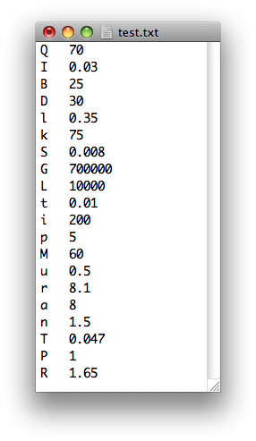
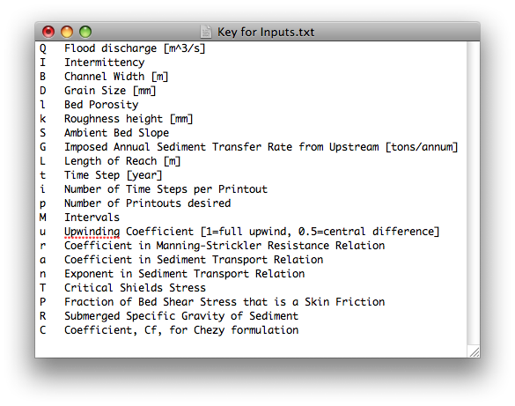

The outputs of the model are N_{print} longitudinal profiles at different times t_{plot,j}
, j = 1…N_{print} (5.viii)
An example of the output file Output.txt is reported in the window below with an example of the additional parameters that the user may want to plot in the text file Output1.txt, i.e. bed slope, S, water depth, H, Shield’s number, τ_{b}, and the total bed material load, q_{t}. The initial bed profile is the bed profile at mobile-bed equilibrium, given the water discharge, the flow intermittency and the initial bed slope.
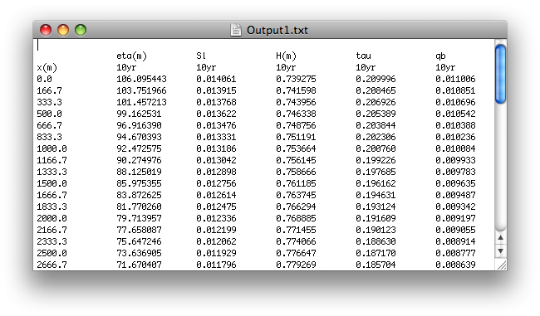
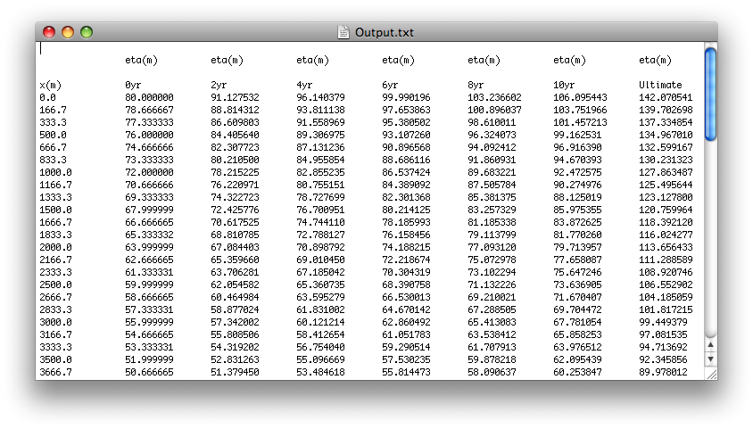

Notes:
- The maximum number of computational nodes, M, is 99 (this is the case for all of the AgDeg functions)
- Calculates the water depth with a Chézy formulation, if only the Chézy coefficient is specified in the input text file. The code uses a Manning-Strickler formulation, when only the roughness height, k_{c}, and the coefficient α_{r} are given in the input text file. If all these parameters are in the text file, the program will ask the user which formulation he would like to use
- Prompts user whether they would like to append certain parameters (i.e. flow depth at flood, Shield’s number at flood, Einstein number at flood, etc.) to the data file, or write them in a separate file
List of variables

x streamwise coordinate in m
Δx spatial step length in m
t temporal coordinate in seconds
C_{f} non-dimensional friction coefficient

Input
Q_{w} flood discharge in m³/s
I_{f} flood intermittency
B_{c} channel width in m
D characteristic grain size in mm
λ_{p} bed porosity
k_{c} composite roughness height in mm
S_{I} ambient bed slope
G_{tf} imposed annual sediment transport rate in tons/annum
L length of reach in m
Δt time step in yr
N_{toprint} number of timesteps to printout
N_{print} number of printouts
M number of spatial intervals
a_{u} upwinding coefficient (1=full upwind, 0.5=central difference)
α_{r} coefficient in Manning-Strickler
α_{s} coefficient in sediment transport relation
n_{t} exponent in sediment transport relation
reference Shields number in sediment transport relation
ϕ_{s} fraction of bed shear stress due to skin friction
R submerged specific gravity
Cz non-dimensional Chézy friction coefficient

OUTPUT
η bed surface elevation in m
S bed slope
H water depth in m
τ_{b} total boundary shear stress on bed surface N/m²
q_{t} total bed material load in m²/s

References:
de Vries, M. 1965. Considerations about non-steady bed-load transport in open channels. Proceedings, 11th Congress, International Association for Hydraulic Research, Leningrad: 381-388.
Engelund, F. and E. Hansen, 1967, A Monograph on Sediment Transport in Alluvial Streams, Technisk Vorlag, Copenhagen, Denmark.
Paola, C., Heller, P. L. & Angevine, C. L., 1992, The large-scale dynamics of grain-size variation in alluvial basins. I: Theory, Basin Research, 4, 73-90.
Wong M. and G. Parker, 2006, Reanalysis and correction of bed-load relation of Meyer-Peter and Müller using their own database, Journal of Hydraulic Engineering, 132(11), 1159-1168;

